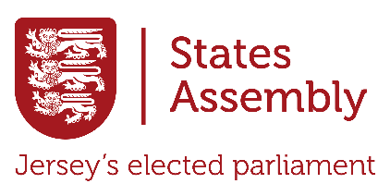

Uncovering Jersey’s States Assembly
Today, you will explore www.statesassembly.je to learn about Jersey’s States Assembly and how it works. Your task is to answer the questions below and complete the Creative Challenge at the end. Use the menu at the top of the website, along with the search, to find out the answers! Write your responses in full sentences and explain your answers in your own words.

- What is the States Assembly?


- How many elected members are in the Assembly, and what are the types of members?

- What is the main responsibility of the States Assembly?

- Who is the Chief Minister, and what do they do?

- What is a Connétable, and who elects them?

- What is the role of the Bailiff in the Assembly?

- What are the steps for creating a new law in Jersey?

- What is a Scrutiny Panel, and why is it important?

- How can members of the public share their views with the Assembly?

- What is one recent topic or issue the Assembly has debated?

Creative Challenge Extension: Design an infographic poster about the States Assembly. Include facts, roles of members, and why the Assembly is important.

