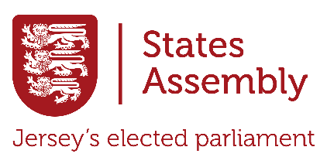

Uncovering Jersey’s States Assembly
Today, you will explore www.statesassembly.je to learn about Jersey’s States Assembly and how it works. Your task is to answer the questions below and complete the Creative Challenge at the end. Use the menu at the top of the website, along with the search, to find out the answers! Write your responses in full sentences and explain your answers in your own words.

- What is the purpose of the States Assembly?


- How many elected members are in the Assembly, and what are the types of members?

- What is the difference between the States Assembly and the Government of Jersey?

- Who is the Chief Minister, and what powers do they hold?

- What responsibilities does the role of Connétable have outside of the States Assembly?

- What is the role of the Bailiff in the Assembly? How does this role differ from that of the elected members?

- Outline the process of how a law is passed in Jersey.

- What is a Scrutiny Panel, and how do they contribute to the democratic process?

- How can members of the public try to influence decisions made by the States Assembly?

- What is one recent topic or issue the Assembly has debated? Why is it significant?

- How many Inter-Parliamentary bodies does the States Assembly participate in? What are they?

- What is the Assemblée Parlementaire de la Francophonie (APF)?

- What is the Commonwealth Parliamentary Association (CPA)?

Extension Activity: Critical Engagement
Choose one of the following tasks to apply your understanding:
- Debate Prep: Research a recent issue debated in the Assembly. Write an argumentative speech either in favor of or against the topic, supported by evidence.
- Proposal for Change: Draft a proposal for a new law or policy you believe Jersey needs. Include the reasons for your proposal and its potential impact on the island.

