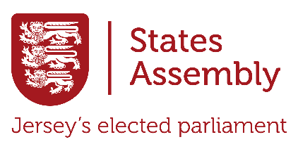

Uncovering Jersey’s States Assembly
Today, you will explore www.statesassembly.je to learn about Jersey’s States Assembly. Your task is to answer the questions below and complete the Extension Challenge at the end. Use the menu at the top of the website, along with the search, to find out the answers! Write your responses in full sentences and explain your answers in your own words.

- What is the States Assembly?


- How many members are there in the States Assembly?

- What is the name of the current Chief Minister?

- What is a Deputy?

- What is a Connétable?

- What is a Scrutiny Panel?

- How does the States Assembly vote on decisions? What are the three options States Member have when they vote?

- What is the name of the current Bailiff?

- How can members of the public share their views with the Assembly?

- What is one recent topic the States Assembly has debated?

Extension Challenge: Once you've answered all the questions, come up with at least two new questions you would like to ask about the States Assembly!

