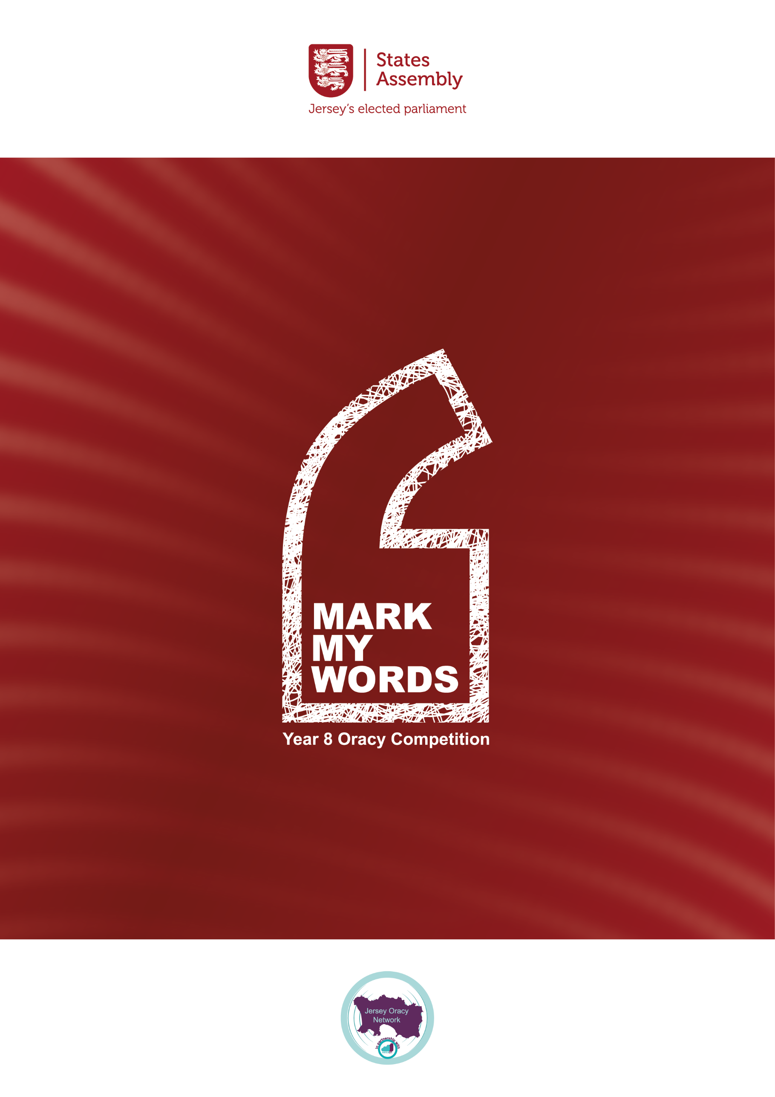

‘MARK MY WORDS’: Year 8 Oracy Competition

Guidance for Teachers

|  |
| --- |
| **AIM:**   * To encourage and equip young people to craft, communicate and critique a proposal for change in our Island. |
| **OBJECTIVES:**   * **To develop and celebrate communication skills through the explicit teaching** of transactional writing, public speaking and effective questioning, building on the experience of the ‘Speak up, Speak out’ Year 6 contest and aligning with the Voice 21 initiative in schools. * To set public speaking within a political context with propositions, speeches and questioning in the States Chamber and in front of politicians. * **To enhance knowledge and understanding of Jersey’s political system** and procedures and to maintain links between the Island’s youth and local politicians. |
| **PLAN:**   * **English Departments** in participating schools will **teach a 3-week unit of work** either in the summer term to Year 7 or in the Autumn Term to Year 8 on: * **1) Crafting 2) Communicating 3) Critiquing a persuasive speech, of up to 3 minutes, that calls for local change.** * **A pack of resources** including a timeline of key dates and deadlines, expected outcomes and suggested activities and resources will be offered to schools at the competition’s launch on the 29th April. * The taught unit will culminate in **every student drafting and delivering a speech of up to 3 minutes calling for a local change** in attitudes or actions on any aspect of these three topics: Conflict, Sustainability or Social Responsibility * **Schools are encouraged to hold internal competitions** by class and then by year group to select a finalist to send to the **main inter-****schools competition on Friday 26th September** (end of Democracy Week). * **Each school can bring up to 6 students to the final** as support for their speaker and to form a team to discuss, draft and deliver questions on the other speeches. * **The overall winner will be decided by the panel of three judges** based on: 1) The **content** of the speech 2) The **delivery** of the speech the speech 3) The quality of **critical thinking** after the speech through effective questions and answers (two questions per speech, alternating between schools) * There will be a **trophy** for the individual winner and a **£500 prize** for the school. |

‘MARK MY WORDS’: Year 8 Oracy Competition

Suggested Lesson Sequence

**N.B. All lesson sequences, allocated timings, suggested activities and provided resources are optional. They can be followed as written, adopted in part or used simply as guidance.**

**WEEK 1: CLARIFICATION – What is expected?**

|  |  |  |
| --- | --- | --- |
| Objectives | Activities | Resources |
| **1) Students receive a clear overview** of the aims and expectations of the task, with explicit reference to the knowledge and skills developed, expected outcomes and timeline. | A) Class Introduction and Explanation:  Use ‘Mark my Words’ PowerPoint slides 1-5 to explain the competition (Welcome video included).  B) Pair/Group/Class Discussion:  **What is a speech? Who makes speeches and why? How have speeches changed the world? How is a speech different to a piece of writing? Why is this skill important?**  C) Watch the Exemplar Speech -  **‘Oracy should be compulsory in Schools’** to emphasise aims and outcome of the competition. | ‘Mark my Words’ PowerPoint slides 1 – 5.  ‘Mark my Words’ PowerPoint slide 6.  **Exemplar Speech VIDEO**. Slide 7 |
| **2) Students study Transactional Writing/Speaking**: Teaching/Reminding students how to analyse and craft a persuasive speech using a wide range of Rhetorical Devices. | **A) Pair/Group/Class Discussion of Rhetorical Devices in Transactional Writing/Speaking:** Ask the students what they remember from their Year 6 experience of the ‘Speak Up, Speak Out’ competition, or any past experience of public speaking or persuasive writing, and gather a wide range of examples.  B) **Revisit/Teach Rhetorical Devices** e.g. The hook, triadic structure, alliteration, repetition, rhetorical questions facts and statistics, analogies and anecdotes, figurative language, direct address to the audience, comparisons, rhymes and quotes, call to action, summary.  C) Students play ‘Rhetorical Device Bingo’ whilst listening again to the provided example of a persuasive speech Video 1: ‘Why Oracy should be compulsory in schools’ (using Worksheet 1)  D) Students introduced to the Hook/ Diagnosis/ Vision/Plan structure for a persuasive speech.  D) Students to annotate the transcript of the exemplar speech to find specific examples of Rhetorical Devices and to identify the different sections of the speech’s structure (Worksheet 2) | ‘Mark my Words’ PowerPoint slides 8 – 9.  ‘Mark my Words’ PowerPoint slides 10 – 24.  **Slides 25 - 28**  Worksheet 1) Crafting a Speech: The Rhetorical Devices Bingo Card  Video containing Exemplar Speech.  Worksheet 2)  Crafting: Spotting the structures in a speech. |

**WEEK 1/2: CRAFTING – How to structure a speech**

|  |  |  |
| --- | --- | --- |
| Objectives | Activities | Resources |
| 3) Students use Rhetorical Devices and Writing Frame to craft their own persuasive speech that identifies a current local problem and argues for change. | **A) Schools to pick a topic/issue for their speech** from the 3 broad themes of **Conflict, Sustainability or Social Responsibility** and give students a period of time to consider/discuss an issue that is of interest to them. (See p. 6/7 of this document for ideas)  Please Note: It is up to individual Departments whether all students present different proposals on different themes, or different proposals on the same theme or respond to exactly the same title/proposition.  B) Students to craft their speech according to suggested Hook/Diagnosis/Vision/Plan template (Worksheet 3)  C) Students to proof-read, edit and improve their speech using the Crafting Checklist (Worksheet 4) | ‘Mark my Words’ PowerPoint slides Slide 29 - 32.  Slides 33 - 34  Worksheet 3)  Crafting: How do I structure a speech?  Worksheet 4)  Crafting Check Is my speech well structured? |

**WEEK 2/3: COMMUNICATING – How to present a speech**

|  |  |  |
| --- | --- | --- |
| Objectives | Activities | Resources |
| **4) Students revisit/study Public Speaking skills:**  **the ability to c**ommunicate a persuasive speech in a clear, convincing and engaging manner using voice, face and body. | A) Pair/Group/Class Discussion: What physical skills should be used when delivering your speech?  Extra Prompt if needed – Think about what you need to do with your voice, face and body.  **B) Revisit/Teach students about physical skills when public speaking** – use of **voice** (fluency, volume, pace, pause, pronunciation, enunciation, intonation); **face** (expression and eye contact) and **body** (posture, stance, gesture).  C) Pair/Group/Class Discussion: Why are these physical skills as important as the writing skills when it comes to public speaking?  **D) Students to watch the exemplar speech again** (Video 1) and **identify physical skills in the video** using Worksheet 5: Communicating: How do I take a speech from page to stage? | ‘Mark my Words’ PowerPoint slide  **35.**  ‘Mark my Words’ PowerPoint slide  **36-38.**  ‘Mark my Words’ PowerPoint slide  **39.**  Worksheet 5: Communicating: ‘How do I take a speech from page to stage?’ Slide 40. |

**WEEK 3: COMMUNICATING – Continued**

|  |  |  |
| --- | --- | --- |
| Objectives | Activities | Resources |
| **5) Students evaluate, rehearse and improve their Public Speaking skills: practising their speech and in front of others.** | **A)** Pair/Group/Class Discussion: **Students to consider their strengths and weaknesses in public speaking and what aspect of their voice, face and body they will need to work on the most.**  **B) Students to practise presenting their own speech with minimal prompts** (perhaps just a story map or cue cards) and with a focus on physical skills - body, face and voice:  First on their own (perhaps for homework) and then in front of a trusted partner.  **C) Students to evaluate their presentation skills, with the help of their trusted partner,** by filling in the Communication Checklist (Worksheet 6) | ‘Mark my Words’ PowerPoint slide  **41.**  ‘Mark my Words’ PowerPoint slide  **42.**  Slide 43  Worksheet 6: Communication Checklist: ‘Am I speaking well?’ |

**WEEK 3: CRITIQUING – How to question and challenge**

|  |  |  |
| --- | --- | --- |
| Objectives | Activities | Resources |
| **6) Students revisit and develop their critical thinking skills with a focus on s**ummarising, evaluating and questioning the propositions of others and responding effectively to questions on their own proposition. | A) Pair/Group/Class Discussion: **Students to consider their role as a critically thinking audience – how can they listen to and question other speeches effectively?**  **B) Revisiting effective listening and questioning** - ‘Summarise, Build, Probe, Challenge, Clarify’.  **C) Students to watch the exemplar speech again** (VIDEO) and fill out Worksheet 7 – Critiquing Task A): Can I question, clarify and challenge?’  with sections to ‘Summarise, Build, Probe, Challenge, Clarify’ that will help them to listen carefully to the arguments presented, note down key points and consider what questions they would raise in response. Feedback ideas to class.  **D) Students to watch the VIDEO of exemplar questions and answers to the oracy speech** and identify what Question Types (as outlined above) they have heard by filling out Worksheet 8 - Critiquing Task B) How to question and respond.  **E) Student practice Q and A:** Students to get into pairs, threes or fours and deliver their speech to each other with the listeners crafting and posing questions that the speaker will answer on the spot using the Critiquing Checklist (Worksheet 9). | ‘Mark my Words’ PowerPoint slide  **44.**  ‘Mark my Words’ PowerPoint slide 45.  Worksheet 7 – Critiquing Task A): Can I question, clarify and challenge?  **Slide 46.**  ‘Mark my Words’ PPT slides **47-49.**  Worksheet 8 - Critiquing Task B) How to question and respond.  Worksheet 9 - Critiquing Checklist – Can I question/respond? |

**SUCCESS CRITERIA**

|  |
| --- |
| **For Schools:** |
| * All Year 8 students recognise, develop and use the skills of transactional writing, public speaking and critical thinking with greater confidence. * All Year 8 students practise forming, arguing and delivering a proposition and fielding questions without notice. * All Year 8 students understand public speaking within a political context. * Some Year 8 students revisit the States Chamber and gain experience of delivering a proposition, posing and fielding questions and voting. |
| **For Students:** |
| * All Year 8 students write a persuasive speech, of **up to 3 minutes**, arguing for a particular change or improvement in Jersey. * All Year 8 students present their speech to their peers and respond to questions. * All Year 8 students frame questions in response to the speeches they hear **to clarify, probe, build or challenge.** * All Year 8 students revisit and develop the skills of transactional writing, public speaking and critical thinking. * Some Year 8 students deliver their speech and participate in questioning at competition level within the States Chamber. |

**FINAL CHALLENGE: ‘MARK MY WORDS COMPETITION**

|  |
| --- |
| **INTERNAL COMPETITIONS: Summer/Autumn Term 2025** |
| Class competition – Students deliver speeches and answer questions – class winner  Year group competition – Class winners compete to find overall school winner |
| **EXTERNAL COMPETITION – Friday 26th September 2025** |
| Each school sends Year 8 finalist to the main competition at the States Chamber. **A maximum of 5 other Year 8 students can accompany them to form a team that will craft and pose questions to the finalists from other schools.** |

**ADDITIONAL RESOURCES:**

**Transcripts of famous speeches for study/annotation**

[**40 Most Famous Speeches In History | HighSpark**](https://highspark.co/famous-persuasive-speeches/#:~:text=Land%20where%20my%20father%27s%20died,in%20America%20at%20the%20time.)

**Videos of famous speeches (accessible online)**

**Najee Hackett and other Jack Petchy Speak Out winners**

**Malala Yousafzai’s Nobel Prize acceptance speech**

**Emma Watson’s ‘HeForShe’ speech at the UN in 2014**

**Michelle Obama’s ‘When they go low, we go high’ (Democratic National Convention 2016**

**UK Youth parliament speeches (YouTube)**

**ORACY GAMES: Could be used as icebreakers or lesson starters**

***See Voice 21 – Springboards for Talk Pack 1 online for more information***

**‘Would you rather?’ Icebreaker** - In pairs, two different options ‘Would you rather be poor and happy or rich and unhappy’? Pros/cons for each choice and then an answer.

**‘Talking Points’** – Small groups - Discussion points (2 or 3) to elicit views/thoughts and not ‘correct’ answers. E.g. ‘The purpose of a story is to entertain the reader’. Hands up to offer view or pass the bean bag.

**‘Consensus Circles’** – individuals in a group, brainstorm ideas to a specific question on the outside of a sheet of paper and then collaborate to put mutually agreed ideas in the inner consensus circle.

**‘Which one does not belong?’** – In small groups students are presented with four images/words/numbers that could all be the odd one out and then propose and discuss which one they think is and why (hypothesising, reasoning, justifying).

**‘If I ruled the world’** – Partners (could also be done in a line of partners continually moving round, or in a circle clockwise) Each student says what they would do if they ruled the world and why, and their partner must disagree politely and explain why (even if they agree).

**‘Always, Sometimes, Never’** – students in small groups – give them a series of statements and ask if each one is always, sometimes or never true. Students use reasoning skills and provide proof to justify their conclusions, others will challenge, probe and clarify.

**SPEECH CRAFTING: Choosing topics and building arguments**

**Here are some ideas for how this stage can be structured:**

1. **Carousel: pupils take part in a carousel brainstorming topics/issues for each of the three themes – Conflict, Sustainability and Social Responsibility. Pupils then choose which topic they would like to explore more based on this introduction.**
2. **Honing a topic: Once students have chosen a topic/issue that they are passionate about, they must then hone this topic, so that the subject of their speech is focused and not too broad. Instead of simply writing a speech about ‘Nutrition’ for example, a student may choose to talk about why ‘All Primary students should be entitled to free school meals.’**

**Here are some strategies to support students to hone the subject of their speech:**

* **Snowball: Students write the overarching subject of their speech in the middle of a piece of paper e.g. Poverty, they then screw the piece of paper into a ball. When the teacher claps or blows a whistle, all students throw their ‘snowballs’ into the air. Students then pick up another student’s ‘snowball’ and unravel it. They then draw a line from the central subject and add another, more specific idea, linked to this subject, for example, ‘Charities should receive more funding from the Government.’ The process is then repeated again a number of times, with the next students adding more ideas, such as ‘The really rich should pay more tax.’**
* **5 whys: In this activity students are placed in pairs. The first students tells their partner the subject of their speech e.g. ‘air pollution’. Their partner then asks them why they have chosen this subject and the first student explains, for example, ‘I have chosen this because air pollution is dangerous and we must reduce it’. Their partner then asks ‘why?’ again. This continues until the student has asked 5 whys. When this process is complete, the student answering the questions should have a much clearer idea of why they have chosen their topic and why it is particularly important to them, supporting them to refine the subject of their speech, making their argument more focused and specific.**

* **Some people think...but I think: Present pupils with an image or concept e.g. ‘the zoo’ and ask students to decide what some people think about this, for example, ‘some people think a day out at the zoo is fun.’ Then ask students to flip this perspective and explain what they think, for example, ‘but I think the zoo is cruel.’**

1. **Research: Pupils could then research their topic/issue/proposal independently or break off into different groups based on interest to explore a topic further. Depending on ability and support needs, pupils could be provided with a range of different research packs and/or links to interesting, age-appropriate blogs, websites or videos. You can find local context research and links to relevant propositions on the States Assembly website which could prove helpful.**